CURATOR BIOGRAPHIES

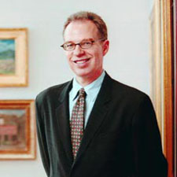
Patterson Sims has worked in the arts since 1969. He began his career as assistant director of O.K. Harris Works of Art, in the then newly developing arts district of Soho in New York City. He was the first curator designated to oversee the permanent collection of the Whitney Museum of American Art, where he worked from 1976 to 1987. During that time he was involved with exhibitions which include the 1977 and 1979 Whitney Biennials; The Decade in Review: Selections from the 1970s (1979); Reginald Marsh: Selections from the Felicia Meyer Marsh Bequest (1979); and a retrospective of Jan Matulka's work (1979). After his time at the Whitney Museum, he began working as the associate director for art and exhibitions and curator of modern art at the Seattle Art Museum. Sims attended the New School for Social Research (1971) and earned a BA in the humanities from Trinity College-Hartford.

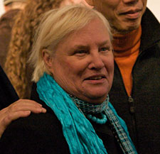
Marion Stroud founded the Fabric Workshop and Museum (FWM) in Philadelphia, Pennsylvania, in 1977. Stroud’s goal was to create a non-profit workshop that combined teamwork and innovation. The Artists in Residency program provided space, tools, and assistance for the artists to make functional objects through screen printing on fabric. Over the years, the residency has expanded to include the creation of non-functional objects, allowing artists to expound on the meaning of the word “fabric.” As founder and artistic director of the FWM, Stroud has curated numerous exhibitions and commissioned works by internationally acclaimed figures in contemporary art, including Louise Bourgeois, Felix Gonzalex-Torres, Ann Hamilton, Reverend Howard Finster, Anish Kapoor, Robert Kushner, Glenn Ligon, Robert Morris, Robert Venturi and Denise Scott Brown, and Carrie Mae Weems. She is the author of New Material as New Media: The Fabric Workshop and Museum and the editor ofWilliam Wegman: Dogs on Rocks, among other exhibition catalogues and artist monographs.

